Practical No. 1

Name : Danish Altaf Solkar Class : CO - B
Enrolment no. : 24111590805 Batch : 2

Aim : a) Identify IP allocations and Internet Service Providers for a Student Network using WHOIS

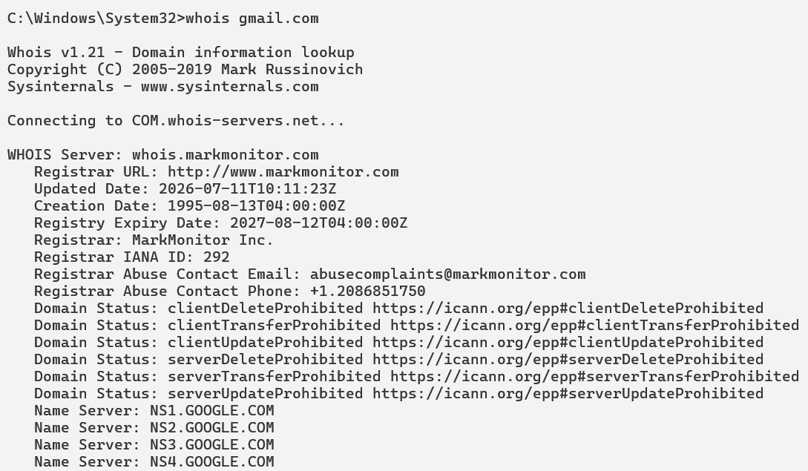

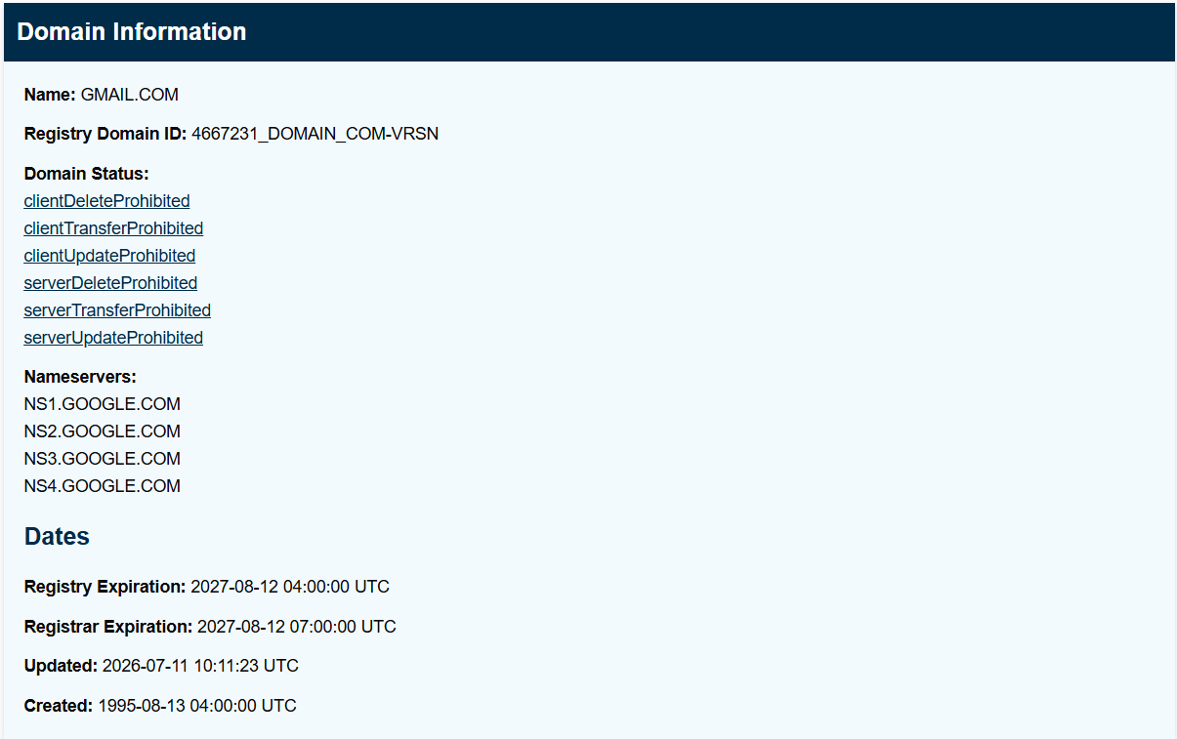

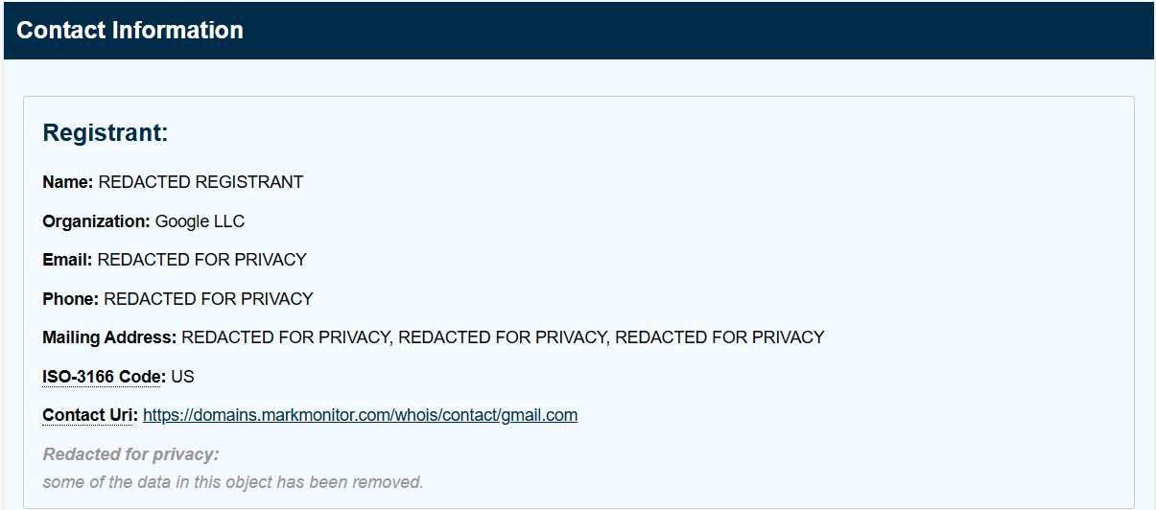

Aim : b) Set up IP Addresses and Subnet Masks on given Network Devices

